TUMELO CYNTHIA LAMOLA  
ST10147766  
WEDE5020  
DIS1 GROUP 2  
POE PART 3  
DUE DATE: 15 NOVEMBER 2023

Table of Contents

**Part 1 with improvements** 5

Website Choice: Include name, description, and reason for choosing the organisation.  [Not less than 300 words] 5

Website Assets: Include any sourced or created text, photos, or graphics that you intend to use/ Gallery 6

Chip-On-Board/Circuit 6

Multi-Chip-Module 6

Multi-Chip-Module 7

Chip-On-Module 7

Chip-On-Module 7

Website Pages and Content 8

Homepage 8

Product and Services 8

About Us 10

Contact Us 11

**Part 2 with improvements:** 11

**Improvements to Part 1 process document** 11

Website Choice: Include name, description, and reason for choosing the organisation. 12

[Not less than 300 words] 12

Website Assets: Include any sourced or created text, photos, or graphics that you intend to use/ Gallery 13

Chip-On-Board/Circuit 13

Multi-Chip-Module 13

Multi-Chip-Module 14

Chip-On-Module 14

Chip-On-Module 14

Website Pages and Content 14

Homepage 14

Product and Services 15

About Us 17

Contact Us 18

**Improvements to Part 1 website** 18

Homepage 18

Products and Services 19

About Us 19

Contact Us 20

**Part 3 with improvements** 21

**Improvements to Part 2 process document.** 21

Website Assets: Include any sourced or created text, photos, or graphics that you intend to use/ Gallery. 22

Chip-On-Board/Circuit 22

Multi-Chip-Module 23

Multi-Chip-Module 23

Chip-On-Module 23

Chip-On-Module 23

Website Pages and Content 24

Homepage 24

Product and Services 24

About Us 26

Contact Us 27

**Improvements to Part 2 website** 27

Homepage 27

Products and services 27

Gallery 28

Contact Us 28

About Us 28

Functionality 28

SEO 30

References 32

# **Part 1 with improvements**

# Website Choice: Include name, description, and reason for choosing the organisation.  [Not less than 300 words]

3D-PRINTING & TECH.SUPP is known well known for offering their customers with the 3D printing business that is within technology and innovation. We utilize a wide range of technologies for electronic assemblies. Electronic assembly involves gathering, soldering, or integrating electronic components and circuits to perform one or more distinct functions. It manufactures electronic components and computer parts. In our company we ensure the practicality of a printed circuit board (PCB) which is part of the electronic gadgets.

We also aim to Serve the current and future generations within the 3D printing organizations and empower learners and educators through the integration of 3D printing technology into education. Our work entails providing 3D printing services to companies and organizations and providing training, and fostering hands-on learning experiences, we aim to equip the next generation with critical skills required for the future job market. Our focus on underprivileged communities ensures that every learner, regardless of their background, has an equal opportunity to explore and benefit from 3D printing technology. We envision a future where every school has access to 3D printing resources, fostering a culture of innovation, and preparing learners for success in a rapidly evolving world. We utilize a wide range of technologies for electronic assemblies. A typical electronic assembly normally consists of the 3D printing machines that helps create multi-chip module and chip-on-board assembly. While the It Setup normally consists of computers, servers, network infrastructure consisting of a router and Wi-Fi backup package and telephony system. Basically, on the Tech side we upgrade the PCs old software to the fastest and most reliable ones.

I chose this organisation because it is unique, and it offers a wide range of technologies for electronic assemblies that consist of Chip-On-Board and Multi-Chip Module. It also focuses on empowering learners and educators and offer customizable learning solutions that include, educational packages or bundles that include 3D printers, software, and materials tailored for educational settings.

# Website Assets: Include any sourced or created text, photos, or graphics that you intend to use/ Gallery

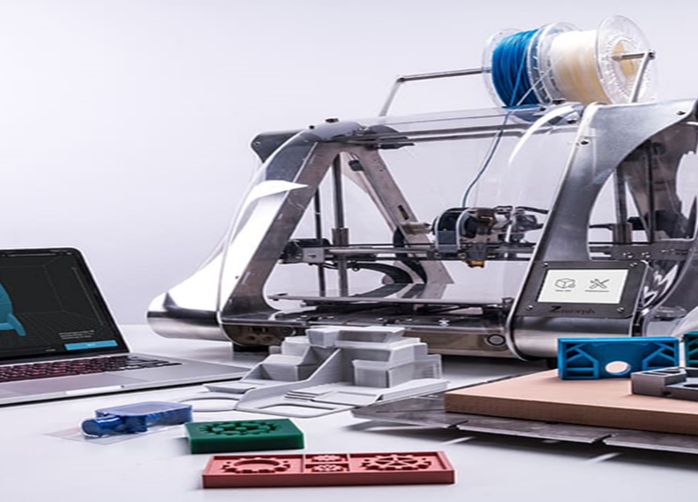

## Chip-On-Board/Circuit

## Multi-Chip-Module

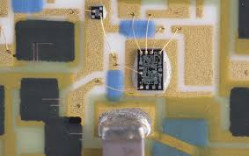

## Multi-Chip-Module

## Chip-On-Module

## Chip-On-Module

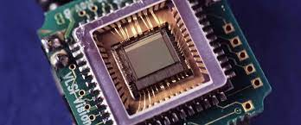

# Website Pages and Content

## Homepage

3D-PRINTING & TECH.SUPP is known well known for offering their customers with the 3D printing business that is within technology and innovation. We utilize a wide range of technologies for electronic assemblies. Electronic assembly involves gathering, soldering, or integrating electronic components and circuits to perform one or more distinct functions. It manufactures electronic components and computer parts. In our company we ensure the practicality of a printed circuit board (PCB) which is part of the electronic gadgets.

## Product and Services

Product description

Our services consist of two types of effective assemblies which is CHIP-ON-BOARD and MULTI-CHIP MODULE

CHIP-ON-BOARD ASSEMBLY

This is a new packaging method far different from the surface mount device (SMD) package technology. The chip on board (COB) assembly offers more advantages and this package can be found in the smallest of all electronic devices. A chip on board is a bare chip mounted directly on the printed circuit board (PCB). A ball of plastic covers the chip to create a connection, only after the wires have connected. In addition, the technician wires the bare chip to the board and uses epoxy resin to pour it into it. The chip on board follows three steps to make a chip which include, die mount, wire bonding, and encapsulation of the wires and dies.

THE BENEFITS OF CHIP ON BOARD

* Enhanced protection against reverse-engineering
* Fewer costs
* Minimized interconnection resistance and lengths.
* Improved performance
* Reliability because of heat distribution
* Minimized space requirements.
* Shorter time to market
* Small number of solder joint
* Less weight on the circuit

MULTI-CHIP MODULE

This is an electronic package consisting of multiple integrated circuits assembled into a single device that allows one multi-chip module to host more combined circuits. Components of multi-chip-module (MCM) are mounted on a substrate, and wire bonding, tape bonding, or flip-chip bonding are used to connect the bare dies of the substrate. The MCM is mounted on the printed circuit board, and it can be encapsulated by a plastic moulding.

THE BENEFITS OF MULTI-CHIP MODULE

* Offers better performance.
* Lower power supply inductance
* Lower off-chip driver power
* Reduced size
* Low-cost silicon sweep
* Helps in the integration of different semiconductor technologies.
* Reduced complexity
* Simplified design
* reliable

The following are the areas in which 3D-PRINTED TECH will specialize in serving the customers and schools. Companies and their technicians will no longer have to assemble pc boards by painstaking means of soldering each component by hand. Our company offers to print assembled pc boards because they save time, labor costs, and space is taken up by the circuits. We will also do the following:

**1. Identifying Partner Schools:**

The first step for 3D-PRINTING TECH.SUPP is to identify partner schools and educational institutions in South Africa that would benefit from integrating 3D printing technology into their curriculum. We collaborate with schools in underprivileged communities or those lacking access to advanced resources.

**2. Needs Assessment and Training:**

Once the partner schools are identified, our team conducts a needs assessment to understand their specific requirements, resources, and existing capabilities. We offer training programs for teachers and staff to familiarize them with the fundamentals of 3D printing technology, including design software, hardware operation, and safety protocols.

**3. Curriculum Integration:**

To ensure effective integration of 3D printing technology into the education system, we work closely with partner schools to develop curriculum modules that incorporate hands-on learning experiences using 3D printers. This includes designing age-appropriate projects and activities that align with the national curriculum standards and encourage critical thinking, problem-solving, and creativity.

**4. Access to 3D Printing Technology and Resources:**

3D-PRINTING TECH.SUPP provides partner schools with 3D printers, filaments, and other necessary equipment to establish dedicated 3D printing labs or makerspaces within their premises. We guide schools in the selection and setup of equipment, ensuring they receive ongoing technical support and maintenance assistance.

**5. Workshop and Outreach Programs:**

In addition to supporting partner schools, 3D-PRINTING TECH.SUPP also conducts workshops and outreach programs for students from a wider range of schools. These programs offer students hands-on experiences with 3D printing technology, fostering creativity, and igniting interest in advanced manufacturing. We also collaborate with other NGOs or educational organizations to reach a greater number of learners.

**6. Mentorship and Project Collaborations:**

To further enhance the impact of 3D printing technology, 3D-PRINTING TECH.SUPP facilitates mentorship programs and project collaborations between partner schools and industry professionals. This exposes learners to real-world applications of 3D printing, expands their horizons, and helps them build valuable skills and networks.

## About Us

**SWOT ANALYSIS**

**STRENGTHS**

We are motivated by innovative activity and dedication in an environment where we learn and share with our team members. We have established and maintained a strong financial status.

* Low-cost manufacturing
* Leadership in product innovation
* Teamwork
* Strong employees
* Good customer service

**WEAKNESSES**

There are lots of new stuff to train and structures to learn. We sometimes feel like we don’t give our customers our best. This often led us to overwork ourselves and do what was best for our customers. We also deal with too many projects at once and that makes us forget to do other work-related things.

* Creativity
* Taking on risks
* Sharing responsibility
* Dealing with too many projects at once

**OPPORTUNITIES**

* New innovation
* Weaknesses of our competitors
* New packaging
* Internships for students

**THREATS**

* Decreased income
* Competitors actions
* New competitors

**OPERATING PLAN**

3D-PRINTING TECH.SUPP offer small and big organizations different plans to sustain them. We offer small companies a contract of 6 months with limited credit to pay back for the products they purchased from us like our electronic assembly products. We offer large organizations a long duration of time so that they could be able to come and do their second purchase. We offer them a long duration of time to pay all the amount because they usually do large purchases, and we are their supplier. Our customers that require IT services need to pay the full amount. We offer different services, so our clients will need to contact our offices for full quotation.

**Mission and Vision:**

Our mission is Empower and Serve the current and future generations within 3D printings organizations. Also, to bridge the gap between traditional education and advanced manufacturing by providing access to cutting-edge 3D printing technology and resources. By fostering innovation and hands-on learning experiences, we strive to equip individuals with the skills and knowledge needed for the industries of the future.

Our vision as 3D-PRINTED Technical Support is to assume our primary goal, which is to provide our customers with the most comprehensive and flexible wide range of technologies for effective assembly. We do not only serve large organizations and businesses, but also schools; our prime objective is to provide exceptional service in all elements, and our staff will be fully trained and knowledgeable about this goal.

## Contact Us

Get in touch using the form, or send us an email, and we’ll get back to you as soon as we can. For any urgent issues, please give us call.

**Email**

[ST10147766@rcconnect.edu.za](mailto:ST10147766@rcconnect.edu.za)

**Call**

078 542 3124

# **Part 2 with improvements:**

# **Improvements to Part 1 process document**

# Website Choice: Include name, description, and reason for choosing the organisation.

# [Not less than 300 words]

3D-PRINTING & TECH.SUPP is known well known for offering their customers with the 3D printing business that is within technology and innovation. We utilize a wide range of technologies for electronic assemblies. Electronic assembly involves gathering, soldering, or integrating electronic components and circuits to perform one or more distinct functions. It manufactures electronic components and computer parts. In our company we ensure the practicality of a printed circuit board (PCB) which is part of the electronic gadgets.

We also aim to Serve the current and future generations within the 3D printing organizations and empower learners and educators through the integration of 3D printing technology into education.

Our work entails providing 3D printing services to companies and organizations and providing training, and fostering hands-on learning experiences, we aim to equip the next generation with critical skills required for the future job market. Our focus on underprivileged communities ensures that every learner, regardless of their background, has an equal opportunity to explore and benefit from 3D printing technology. We envision a future where every school has access to 3D printing resources, fostering a culture of innovation, and preparing learners for success in a rapidly evolving world. We utilize a wide range of technologies for electronic assemblies. A typical electronic assembly normally consists of the 3D printing machines that helps create multi-chip module and chip-on-board assembly. While the It Setup normally consists of computers, servers, network infrastructure consisting of a router and Wi-Fi backup package and telephony system. Basically, on the Tech side we upgrade the PCs old software to the fastest and most reliable ones.

I chose this organisation because it is unique, and it offers a wide range of technologies for electronic assemblies that consist of Chip-On-Board and Multi-Chip Module. It also focuses on empowering learners and educators and offer customizable learning solutions that include, educational packages or bundles that include 3D printers, software, and materials tailored for educational settings.

# Website Assets: Include any sourced or created text, photos, or graphics that you intend to use/ Gallery



## Chip-On-Board/Circuit

## Multi-Chip-Module

## Multi-Chip-Module

## Chip-On-Module

## Chip-On-Module

# Website Pages and Content

## Homepage

3D-PRINTING & TECH.SUPP is known well known for offering their customers with the 3D printing business that is within technology and innovation. We utilize a wide range of technologies for electronic assemblies. Electronic assembly involves gathering, soldering, or integrating electronic components and circuits to perform one or more distinct functions. It manufactures electronic components and computer parts. In our company we ensure the practicality of a printed circuit board (PCB) which is part of the electronic gadgets.

## Product and Services

PRODUCT DESCRIPTION

Our services consist of two types of effective assemblies which is CHIP-ON-BOARD and MULTI-CHIP MODULE

CHIP-ON-BOARD ASSEMBLY

This is a new packaging method far different from the surface mount device (SMD) package technology. The chip on board (COB) assembly offers more advantages and this package can be found in the smallest of all electronic devices. A chip on board is a bare chip mounted directly on the printed circuit board (PCB). A ball of plastic covers the chip to create a connection, only after the wires have connected. In addition, the technician wires the bare chip to the board and uses epoxy resin to pour it into it. The chip on board follows three steps to make a chip which include, die mount, wire bonding, and encapsulation of the wires and dies.

THE BENEFITS OF CHIP ON BOARD

* Enhanced protection against reverse-engineering
* Fewer costs
* Minimized interconnection resistance and lengths.
* Improved performance
* Reliability because of heat distribution
* Minimized space requirements.
* Shorter time to market
* Small number of solder joint
* Less weight on the circuit

MULTI-CHIP MODULE

This is an electronic package consisting of multiple integrated circuits assembled into a single device that allows one multi-chip module to host more combined circuits. Components of multi-chip-module (MCM) are mounted on a substrate, and wire bonding, tape bonding, or flip-chip bonding are used to connect the bare dies of the substrate. The MCM is mounted on the printed circuit board, and it can be encapsulated by a plastic moulding.

THE BENEFITS OF MULTI-CHIP MODULE

* Offers better performance.
* Lower power supply inductance
* Lower off-chip driver power
* Reduced size
* Low-cost silicon sweep
* Helps in the integration of different semiconductor technologies.
* Reduced complexity
* Simplified design
* reliable

The following are the areas in which 3D-PRINTED TECH will specialize in serving the customers and schools. Companies and their technicians will no longer have to assemble pc boards by painstaking means of soldering each component by hand. Our company offers to print assembled pc boards because they save time, labor costs, and space is taken up by the circuits. We will also do the following:

**1. Identifying Partner Schools:**

The first step for 3D-PRINTING TECH.SUPP is to identify partner schools and educational institutions in South Africa that would benefit from integrating 3D printing technology into their curriculum. We collaborate with schools in underprivileged communities or those lacking access to advanced resources.

**2. Needs Assessment and Training:**

Once the partner schools are identified, our team conducts a needs assessment to understand their specific requirements, resources, and existing capabilities. We offer training programs for teachers and staff to familiarize them with the fundamentals of 3D printing technology, including design software, hardware operation, and safety protocols.

**3. Curriculum Integration:**

To ensure effective integration of 3D printing technology into the education system, we work closely with partner schools to develop curriculum modules that incorporate hands-on learning experiences using 3D printers. This includes designing age-appropriate projects and activities that align with the national curriculum standards and encourage critical thinking, problem-solving, and creativity.

**4. Access to 3D Printing Technology and Resources:**

3D-PRINTING TECH.SUPP provides partner schools with 3D printers, filaments, and other necessary equipment to establish dedicated 3D printing labs or makerspaces within their premises. We guide schools in the selection and setup of equipment, ensuring they receive ongoing technical support and maintenance assistance.

**5. Workshop and Outreach Programs:**

In addition to supporting partner schools, 3D-PRINTING TECH.SUPP also conducts workshops and outreach programs for students from a wider range of schools. These programs offer students hands-on experiences with 3D printing technology, fostering creativity, and igniting interest in advanced manufacturing. We also collaborate with other NGOs or educational organizations to reach a greater number of learners.

**6. Mentorship and Project Collaborations:**

To further enhance the impact of 3D printing technology, 3D-PRINTING TECH.SUPP facilitates mentorship programs and project collaborations between partner schools and industry professionals. This exposes learners to real-world applications of 3D printing, expands their horizons, and helps them build valuable skills and networks.

## About Us

**SWOT ANALYSIS**

**STRENGTHS**

We are motivated by innovative activity and dedication in an environment where we learn and share with our team members. We have established and maintained a strong financial status.

* Low-cost manufacturing
* Leadership in product innovation
* Teamwork
* Strong employees
* Good customer service

**WEAKNESSES**

There are lots of new stuff to train and structures to learn. We sometimes feel like we don’t give our customers our best. This often led us to overwork ourselves and do what was best for our customers. We also deal with too many projects at once and that makes us forget to do other work-related things.

* Creativity
* Taking on risks
* Sharing responsibility
* Dealing with too many projects at once

**OPPORTUNITIES**

* Innovation
* Weaknesses of our competitors
* New packaging
* Internships for students

**THREATS**

* Decreased income
* Competitors actions
* New competitors

**OPERATING PLAN**

3D-PRINTING TECH.SUPP offer small and big organizations different plans to sustain them. We offer small companies a contract of 6 months with limited credit to pay back for the products they purchased from us like our electronic assembly products. We offer large organizations a long duration of time so that they could be able to come and do their second purchase. We offer them a long duration of time to pay all the amount because they usually do large purchases, and we are their supplier. Our customers that require IT services need to pay the full amount. We offer different services, so our clients will need to contact our offices for full quotation.

**Mission and Vision:**

Our mission is Empower and Serve the current and future generations within 3D printings organizations. Also, to bridge the gap between traditional education and advanced manufacturing by providing access to cutting-edge 3D printing technology and resources. By fostering innovation and hands-on learning experiences, we strive to equip individuals with the skills and knowledge needed for the industries of the future.

Our vision as 3D-PRINTED Technical Support is to assume our primary goal, which is to provide our customers with the most comprehensive and flexible wide range of technologies for effective assembly. We do not only serve large organizations and businesses, but also schools; our prime objective is to provide exceptional service in all elements, and our staff will be fully trained and knowledgeable about this goal.

## Contact Us

Get in touch using the form, or send us an email, and we’ll get back to you as soon as we can. For any urgent issues, please give us call.

**Email**

[ST10147766@rcconnect.edu.za](mailto:ST10147766@rcconnect.edu.za)

**Call**

078 542 3124

# **Improvements to Part 1 website**

## Homepage

I fixed line 12 <section class=” header”>

I added <div class=”container,> and < div id=” branding> on line 14 and 15.

Moved the following to line 20 until line 24 and also added <ul> on line 19 and </ul> on line 25 <li><a href="Homepage.html">Homepage</a></li>

        <li><a href="About Us.html">About Us</a></li>

        <li><a href="Products and Services.html">Products and Services</a></li>

        <li><a href="Gallery.html">Vision and Mission</a></li>

        <li><a href="Contact Us.html">Contact Us</a></li>

Added <nav> on line 27, <img src. On line 28 and <div class> on line 29.

Added <section id> on line 35 and the closing one on line 44. Also added, div class=”container” on line 36 and 41.

I added “About our company” on line 45 and made changes from line 51 till 59. Moved footer to line 68 and added new sections from line 69 till 75. Lastly, I made changes on my footer.

## Products and Services

I added <div class=”container,> and < div id=” branding> on line 14 and 15.

I added <nav> on line 18, added <img src= on line 19, added <div class= on line 20, and added <ul> on line 21 and <ul/> on line 27

Moved the following to line 22 until line 26 and also added <ul> on line 19 and </ul> on line 25 <li><a href="Homepage.html">Homepage</a></li>

<li><a href="About Us.html">About Us</a></li>

<li><a href="Products and Services.html">Products and Services</a></li>

<li><a href="Gallery.html">Vision and Mission</a></li>

<li><a href="Contact Us.html">Contact Us</a></li>

I made added and made changed from line 32 until line 80.

 <! ------------------------Footer----------------->

<section class="footer">

    <div class="icons">

        <i class="fa fa-facebook"></i>

                <i class="fa fa-instagram"></i>

                <i class="fa fa-twitter"></i>

                <i class="fa fa-LinkedIn-square"></i>

## About Us

I added <div class=”container,> and < div id=” branding> on line 14 and 15.

I added a logo image on line 21 and made changed on line 22.

Moved the following to line 23 until line 27 and added <ul> on line 22 and </ul> on line 28 <li><a href="Homepage.html">Homepage</a></li>

<li><a href="About Us.html">About Us</a></li>

<li><a href="Products and Services.html">Products and Services</a></li>

<li><a href="Gallery.html">Vision and Mission</a></li>

<li><a href="Contact Us.html">Contact Us</a></li>

I made added and made changes from line 33 until line 39.

I added this footer navigation on line 97 <! ------------------------Footer----------------->

I added the following on line 98 until line 104

<section class="footer">

    <div class="icons">

        <i class="fa fa-facebook"></i>

                <i class="fa fa-instagram"></i>

                <i class="fa fa-twitter"></i>

                <i class="fa fa-LinkedIn-square"></i>

## Contact Us

I added <div class=”container,> and < div id=” branding> on line 14 and 15.

I added a logo image on line 19 and made changed on line 20. Also.

Moved the following to line 22 until line 24 and also added <ul> on line 26 and </ul> on line 21 and 27.

<li><a href="Homepage.html">Homepage</a></li>

<li><a href="About Us.html">About Us</a></li>

<li><a href="Products and Services.html">Products and Services</a></li>

<li><a href="Gallery.html">Vision and Mission</a></li>

<li><a href="Contact Us.html">Contact Us</a></li>

I added this on line 35 <! -----------------------Contact Us Content-------------->

   I made changes and added this on line 36   <section class="Contact Us">

I made the following changes and added new things from line 37 until line 58

        <p>Get in touch using the form, or send us an email, and we’ll get back to you as soon as we can. For any urgent issues, please give us call. </p>

        <div class="row">

            <div class="contact-us-col">

                <i class="fa fa-phone" aria-hidden="true"></i>

                <span>

                    <h3>Call</h3>

                    <p>078 542 3112</p>

                </span>

            </div>

        </div>

        <div class="contact-us-col">

            <i class="fa fa envelope-o"></i>

            <span>

                <h3>Email</h3>

                <p>ST10147766@rcconnect.edu.za</p>

            </span>

        </div>

        <div class="contact-us-col">

            <h3>Operating hours</h3>

            <p>Mon - Fri 08:00 - 16:00<br> Sat 09:00 - 13:00</p>

        </div>

I added <section class> for google form on line 59 and line 62 for location.

I added this footer navigation on line 67 <! ------------------------Footer----------------->

<section class="footer">

    <div class="icons">

        <i class="fa fa-facebook"></i>

                <i class="fa fa-Instagram"></i>

                <i class="fa fa-twitter"></i>

                <i class="fa fa-LinkedIn-square"></i>

# **Part 3 with improvements**

# **Improvements to Part 2 process document.**

Website Choice: Include name, description, and reason for choosing the organisation.

[Not less than 300 words]

3D-PRINTING & TECH.SUPP is known well known for offering their customers with the 3D printing business that is within technology and innovation. We utilize a wide range of technologies for electronic assemblies. Electronic assembly involves gathering, soldering, or integrating electronic components and circuits to perform one or more distinct functions. It manufactures electronic components and computer parts. In our company we ensure the practicality of a printed circuit board (PCB) which is part of the electronic gadgets.

We also aim to Serve the current and future generations within the 3D printing organizations and empower learners and educators through the integration of 3D printing technology into education.

Our work entails providing 3D printing services to companies and organizations and providing training, and fostering hands-on learning experiences, we aim to equip the next generation with critical skills required for the future job market. Our focus on underprivileged communities ensures that every learner, regardless of their background, has an equal opportunity to explore and benefit from 3D printing technology. We envision a future where every school has access to 3D printing resources, fostering a culture of innovation, and preparing learners for success in a rapidly evolving world. We utilize a wide range of technologies for electronic assemblies. A typical electronic assembly normally consists of the 3D printing machines that helps create multi-chip module and chip-on-board assembly. While the It Setup normally consists of computers, servers, network infrastructure consisting of a router and Wi-Fi backup package and telephony system. Basically, on the Tech side we upgrade the PCs old software to the fastest and most reliable ones.

I chose this organisation because it is unique, and it offers a wide range of technologies for electronic assemblies that consist of Chip-On-Board and Multi-Chip Module. It also focuses on empowering learners and educators and offer customizable learning solutions that include, educational packages or bundles that include 3D printers, software, and materials tailored for educational settings.

# Website Assets: Include any sourced or created text, photos, or graphics that you intend to use/ Gallery.



## Chip-On-Board/Circuit

## Multi-Chip-Module

## 

## Multi-Chip-Module

## Chip-On-Module

## Chip-On-Module

# Website Pages and Content

## Homepage

3D-PRINTING & TECH.SUPP is known well known for offering their customers with the 3D printing business that is within technology and innovation. We utilize a wide range of technologies for electronic assemblies. Electronic assembly involves gathering, soldering, or integrating electronic components and circuits to perform one or more distinct functions. It manufactures electronic components and computer parts. In our company we ensure the practicality of a printed circuit board (PCB) which is part of the electronic gadgets.

## Product and Services

**PRODUCT DESCRIPTION**

Our services consist of two types of effective assemblies which is CHIP-ON-BOARD and MULTI-CHIP MODULE.

CHIP-ON-BOARD ASSEMBLY

This is a new packaging method far different from the surface mount device (SMD) package technology. The chip on board (COB) assembly offers more advantages and this package can be found in the smallest of all electronic devices. A chip on board is a bare chip mounted directly on the printed circuit board (PCB). A ball of plastic covers the chip to create a connection, only after the wires have connected. In addition, the technician wires the bare chip to the board and uses epoxy resin to pour it into it. The chip on board follows three steps to make a chip which include, die mount, wire bonding, and encapsulation of the wires and dies.

THE BENEFITS OF CHIP ON BOARD

● Enhanced protection against reverse-engineering

● Fewer costs

● Minimized interconnection resistance and lengths.

● Improved performance

● Reliability because of heat distribution

● Minimized space requirements.

● Shorter time to market

● Small number of solder joint

● Less weight on the circuit

MULTI-CHIP MODULE

This is an electronic package consisting of multiple integrated circuits assembled into a single device that allows one multi-chip module to host more combined circuits. Components of multi-chip-module (MCM) are mounted on a substrate, and wire bonding, tape bonding, or flip-chip bonding are used to connect the bare dies of the substrate. The MCM is mounted on the printed circuit board, and it can be encapsulated by a plastic moulding.

THE BENEFITS OF MULTI-CHIP MODULE

● Offers better performance.

● Lower power supply inductance

● Lower off-chip driver power

● Reduced size

● Low-cost silicon sweep

● Helps in the integration of different semiconductor technologies.

● Reduced complexity

● Simplified design

● reliable

The following are the areas in which 3D-PRINTED TECH will specialize in serving the customers and schools. Companies and their technicians will no longer have to assemble pc boards by painstaking means of soldering each component by hand. Our company offers to print assembled pc boards because they save time, labor costs, and space is taken up by the circuits. We will also do the following:

**1. Identifying Partner Schools:**

The first step for 3D-PRINTING TECH.SUPP is to identify partner schools and educational institutions in South Africa that would benefit from integrating 3D printing technology into their curriculum. We collaborate with schools in underprivileged communities or those lacking access to advanced resources.

**2. Needs Assessment and Training:**

Once the partner schools are identified, our team conducts a needs assessment to understand their specific requirements, resources, and existing capabilities. We offer training programs for teachers and staff to familiarize them with the fundamentals of 3D printing technology, including design software, hardware operation, and safety protocols.

**3. Curriculum Integration:**

To ensure effective integration of 3D printing technology into the education system, we work closely with partner schools to develop curriculum modules that incorporate hands-on learning experiences using 3D printers. This includes designing age-appropriate projects and activities that align with the national curriculum standards and encourage critical thinking, problem-solving, and creativity.

**4. Access to 3D Printing Technology and Resources:**

3D-PRINTING TECH.SUPP provides partner schools with 3D printers, filaments, and other necessary equipment to establish dedicated 3D printing labs or makerspaces within their premises. We guide schools in the selection and setup of equipment, ensuring they receive ongoing technical support and maintenance assistance.

**5. Workshop and Outreach Programs:**

In addition to supporting partner schools, 3D-PRINTING TECH.SUPP also conducts workshops and outreach programs for students from a wider range of schools. These programs offer students hands-on experiences with 3D printing technology, fostering creativity, and igniting interest in advanced manufacturing. We also collaborate with other NGOs or educational organizations to reach a greater number of learners.

**6. Mentorship and Project Collaborations:**

To further enhance the impact of 3D printing technology, 3D-PRINTING TECH.SUPP facilitates mentorship programs and project collaborations between partner schools and industry professionals. This exposes learners to real-world applications of 3D printing, expands their horizons, and helps them build valuable skills and networks.

## About Us

**SWOT ANALYSIS**

**STRENGTHS**

We are motivated by innovative activity and dedication in an environment where we learn and share with our team members. We have established and maintained a strong financial status.

● Low-cost manufacturing

● Leadership in product innovation

● Teamwork

● Strong employees

● Good customer service

**WEAKNESSES**

There are lots of new stuff to train and structures to learn. We sometimes feel like we don’t give our customers our best. This often led us to overwork ourselves and do what was best for our customers. We also deal with too many projects at once and that makes us forget to do other work-related things.

● Creativity

● Taking on risks

● Sharing responsibility

● Dealing with too many projects at once

**OPPORTUNITIES**

● Innovation

● Weaknesses of our competitors

● New packaging

● Internships for students

**THREATS**

● Decreased income

● Competitors actions

● New competitors

**OPERATING PLAN**

3D-PRINTING TECH.SUPP offer small and big organizations different plans to sustain them. We offer small companies a contract of 6 months with limited credit to pay back for the products they purchased from us like our electronic assembly products. We offer large organizations a long duration of time so that they could be able to come and do their second purchase. We offer them a long duration of time to pay all the amount because they usually do large purchases, and we are their supplier. Our customers that require IT services need to pay the full amount. We offer different services, so our clients will need to contact our offices for full quotation.

**Mission and Vision:**

Our mission is Empower and Serve the current and future generations within 3D printings organizations. Also, to bridge the gap between traditional education and advanced manufacturing by providing access to cutting-edge 3D printing technology and resources. By fostering innovation and hands-on learning experiences, we strive to equip individuals with the skills and knowledge needed for the industries of the future.

Our vision as 3D-PRINTED Technical Support is to assume our primary goal, which is to provide our customers with the most comprehensive and flexible wide range of technologies for effective assembly. We do not only serve large organizations and businesses, but also schools; our prime objective is to provide exceptional service in all elements, and our staff will be fully trained and knowledgeable about this goal.

## Contact Us

Get in touch using the form, or send us an email, and we’ll get back to you as soon as we can. For any urgent issues, please give us call.

**Email**

ST10147766@rcconnect.edu.za

**Call**

078 542 3124

# **Improvements to Part 2 website**

I changed the background colour of my website. Also, added the “Cal us” button on the top navigation bar of the website.

## Homepage

<ul link> removed from line 22 to 23.

<div class> “blog-img” removed from line 48 and 55 and “img-src” removed from line 49 and 56.

I added “Receive Newsletter” on line 69-70 above the footer.

I added <div class =” side-nav”> on line 27. Also, added <img src = “images/logo.jpg” class = “logo” on line 28.

## Products and services

Added <align=” center”> under all the h2.

I added <div class =” side-nav”> on line 28. Also, added <img src = “images/logo.jpg” class = “logo” on line 29.

I added <align = “center”> on h1

I added <align = “center”> on all h2. Added <align = “auto”>on line 65 of the paragraph.

## Gallery

I added <div class =” side-nav”> on line 27. Also, added <img src = “images/logo.jpg” class = “logo” on line 28.

I added <align = “center”> on h1 on line 42.

I added <align = “justify”> on all h3.

## Contact Us

I added <div class =” side-nav”> on line 27. Also, added <img src = “images/logo.jpg” class = “logo” on line 28.

I added <align = “justify”> on all h3.

I added a “Customer Contact Form” from line 67-82.

Also, added internal JavaScript from line 85-102 for the button to function and for the sender’s email to go through.

## About Us

I added <div class =” side-nav”> on line 28. Also, added <img src = “images/logo.jpg” class = “logo” on line 29.

I added <align = “center”> on h1 on line 49.

I added <align = “left”> on all h3.

# Functionality

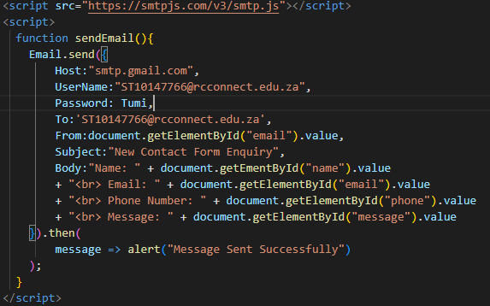

I’ve added internal JavaScript from line 85-102 for the button to function and for the sender’s email to go through.

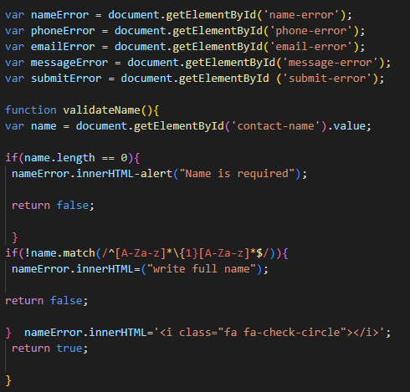

Here, it’s the code that tells the system to read the info under ‘Customer Contact form’ and enables the text info and buttons on the form to function.

There is also a code that requires the customer to enter their full name and if left blank it will pop up a red text written “Name is required”.

**Phone number code**

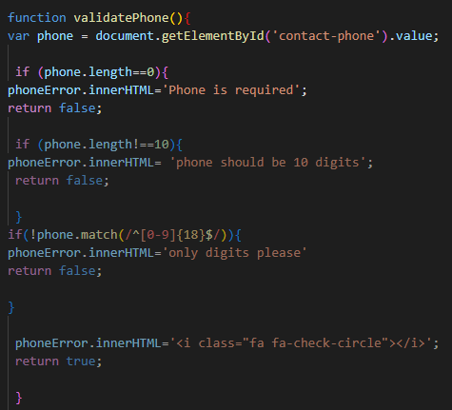

This code requires the customer to enter their phone number and if left blank it will pop up a red text written “Phone is required” and phone number supposed to be 10 digits long and only digits.

**Email and message code**

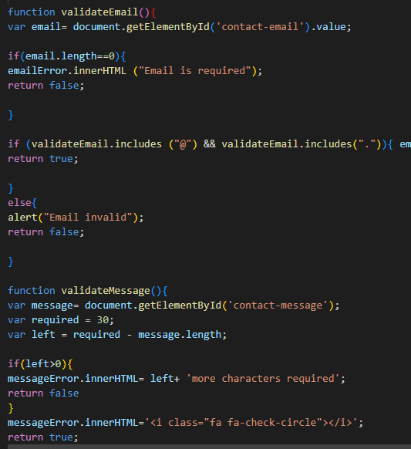

This code requires the customer to enter their email address and if left blank it will pop up a red text written “Email is required” and email without @ will pop up “Email invalid”.

**Validate form code!**

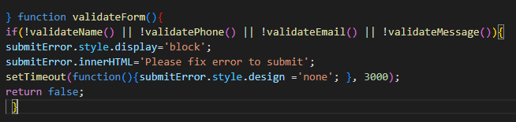

This code validate name, phone, email, and message and submit button. It also fix error before submitting.

# SEO

* Keyword research: I identified relevant keywords and phrases that relate to my website's content and used phrases that customers or people in general will likely to use when searching for my products or services. This helps with improving website’s visibility and increase its chances of ranking higher in search engine.
* High-quality content: Made sure that my website is unique, informative, and has engaging content that catches the reader’s attention. I ensured that it includes the targeted keywords naturally and provides value to the readers.
* On-page optimization: I have optimized crucial on-page elements such as title tags, Meta descriptions, headings and image alt tags. I have optimized my images by using descriptive file names and alt tags.
* Clear site structure: I have organized my website content into distinct categories, subcategories, and pages. I have used a logical and intuitive navigation menu with relevant anchor text to enable individuals who would search for it to understand my site structure.
* Mobile-friendliness: My website is mobile responsive. I have optimized images and used responsive design principles for a seamless user experience across devices.
* Page loading speed: My website page loading speed is faster. I have compressed images, minify CSS and JavaScript files, and enabled browser caching to speed up my website.
* Backlinks: I have built high-quality backlinks from reputable websites to enhance my website’s authority and credibility. This helps establish trust and authority in the eyes of search engines.
* User experience: I have improved user experience by ensuring easy navigation, clear call us buttons, mobile-friendly design, “receive newsletter form, customer contact form and location map and fast-loading pages.
* Regular monitoring and updates: I will continuously monitor my website's performance using analytics tools like Google Analytics. Keep track of my rankings, traffic, and user engagement metrics. Regularly update and refresh my content to maintain relevance.

# References

Anon, 2021. *ITWissen.info.* [Online]   
Available at: https://itwissen.ifo/en/chip-on-board-package-COB-116999.html#gsc.tab=0  
[Accessed 13 September 2023].

Anon, 2023. *Cascade Systems Technology: [Online].* [Online]   
Available at: https://cascadesystems.net/what-is-a-multi-chip-module-assembly/  
[Accessed 13 September 2023].

Anon, 2023. *Rayming Technology. [Online].* [Online]   
Available at: https://www.raypcb.com/chip-on-board-assembly/  
[Accessed 13 September 2023].

The IIE, 2023. *Web Development [WEDE5020 module manual/guide].* 1st: 2012 ed. Johannesburg: The Independent Institute Of Education; unpublished.